# INTRODUCTION

# 1.1 Overview

Salesforce started as a cloud based solution for CRM stands for Customer Relationship Management. It involves managing all aspects of relationship between an organization and its customers. Example the contact details of the customers the deals that at I progress or already completed, the support requests from a customer. Beyond the customer related information, Its also involves strong and managing the details of the people and the concerned department from the seller organization that is managing the customer’s account related and needs. This makes it easy to manage and enhance the relationship with the customer and hence better growth for the organization.

* 1. **Purpose**

CRM Application that help to book a visa slot project help to customers and management. This project a system that is used to track and manage the availability of visa slots, which are appointment that are required for certain visa applications. It might be used by a government agency or a visa processing center to schedule and manage appointment with applicants.

1. **Problem Definition & Design Thinking**
   1. Empathy Map

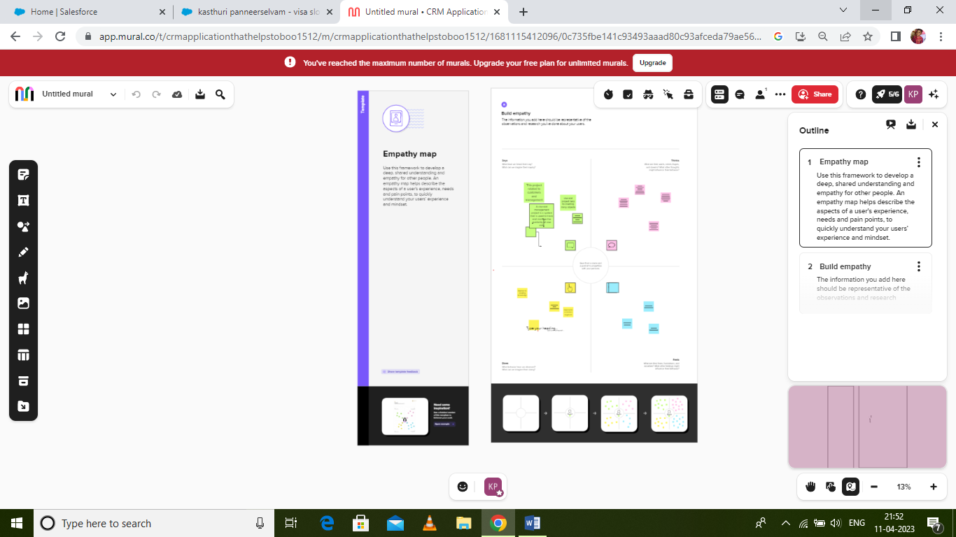

* 1. Ideation & Brainstorming Map

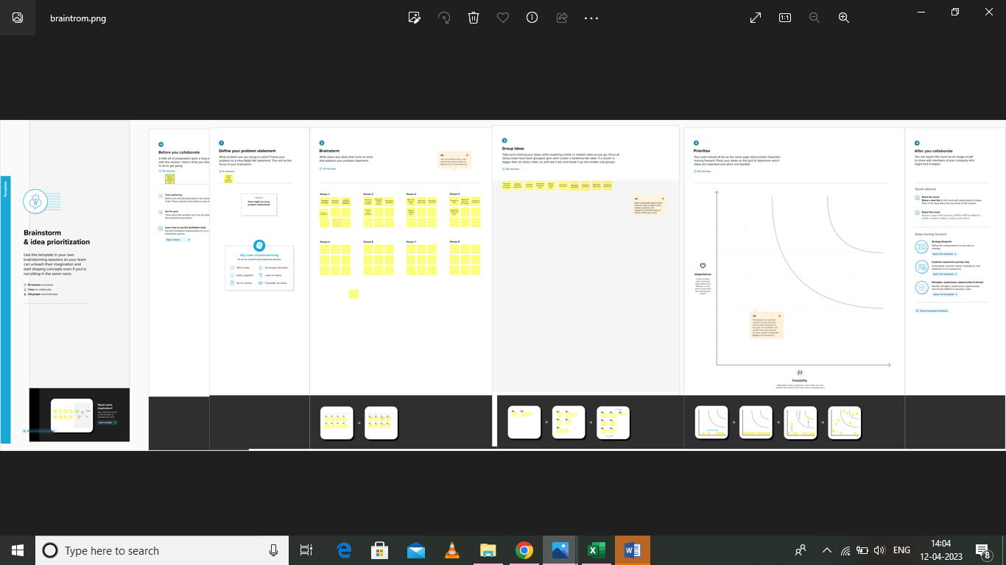

# RESULT

* 1. Data Model:

|  |  |
| --- | --- |
| **Object name** | **Fields in the Object** |
| passport | |  |  | | --- | --- | | Field label | Data type | | Full name | Text | | Passport | Text | | Contact number | Number |   Permanent address Text |
| Visa Slot | |  |  | | --- | --- | | Field label | Data type | | Location | Text | | |  |  | | --- | --- | | Time |  | | Passport Number |  | | Visa slot Number |  | | Text   |  |  |  |  |  |  |  |  | | --- | --- | --- | --- | --- | --- | --- | --- | | |  |  |  |  | | --- | --- | --- | --- | | |  |  | | --- | --- | | Master |  | | Text | | |  | |  | |  | | |  | | |  |  | |  |  | | Field label | | Location | | Time | |
| Payment | Field Data Type   |  |  | | --- | --- | | Payment | Text | | Card Number | Text | | Transaction id | Auto number | | Cancel Transaction   |  | | --- | | Visa slot number | | Text   |  | | --- | | Master | | |
| Reschedule/  cancel | |  |  | | --- | --- | | Passport Number | Master | | Location | Text | | Time | Text | | Cancel | Text | | Status | Text | |

# Activity & Screenshot

# C:\Users\ELCOT\Pictures\Screenshots\Screenshot (3).png

**Milestone-2: Objects:**

**Activity-1:**

**Creation of custom object: Passport**

**1) Navigate to setup and select object manager.**

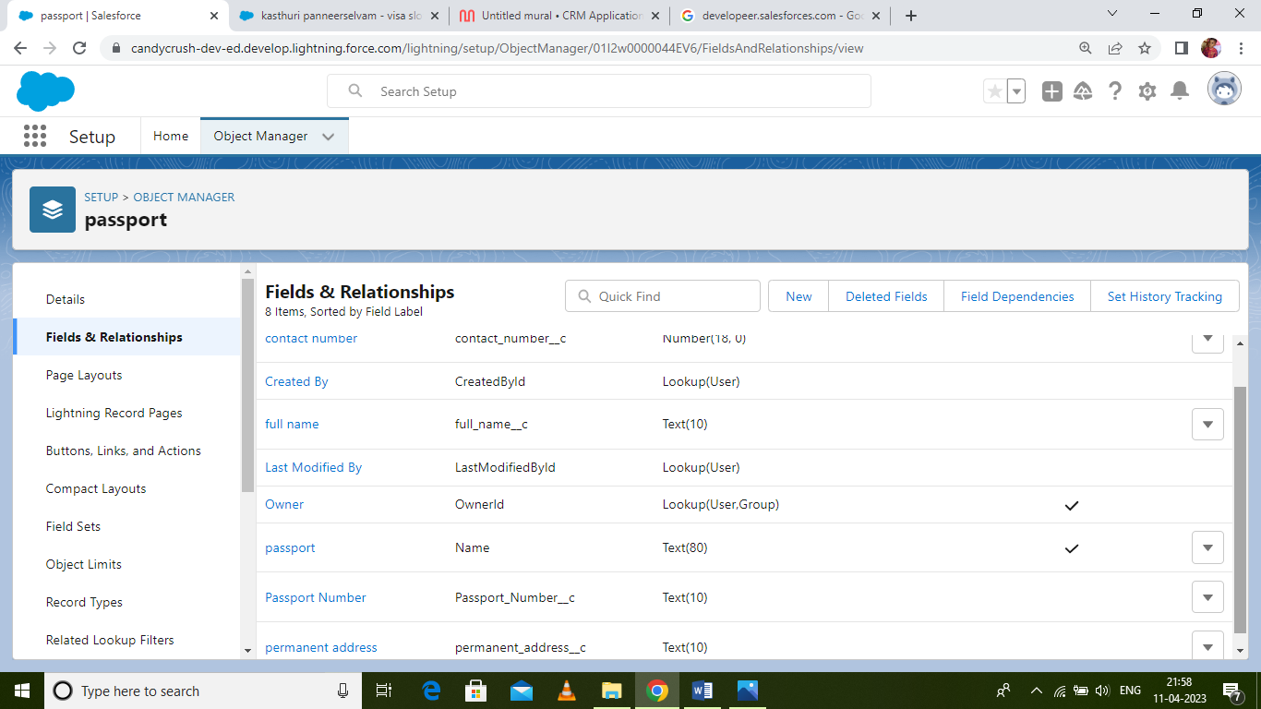

Activity-2:

Fields available on custom object: Passport

Field Name Data Type

1) Contact Number Number

2) Full Name Text

3) Passport Number Text

4) Permanent Address Text

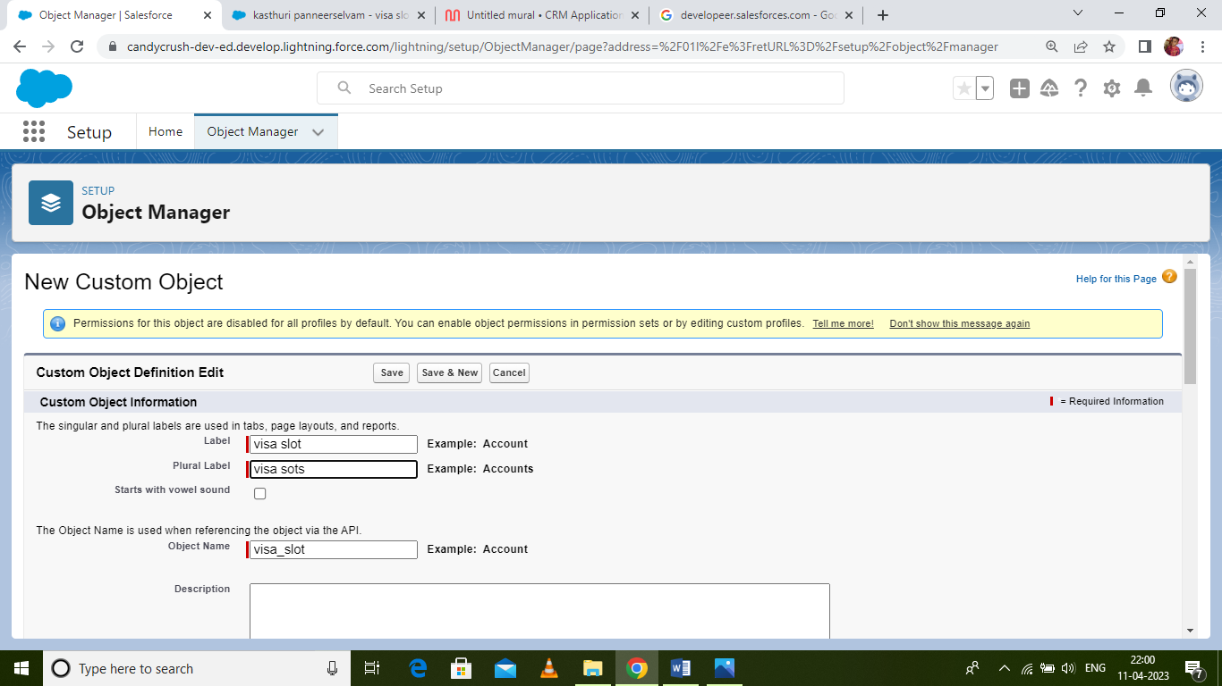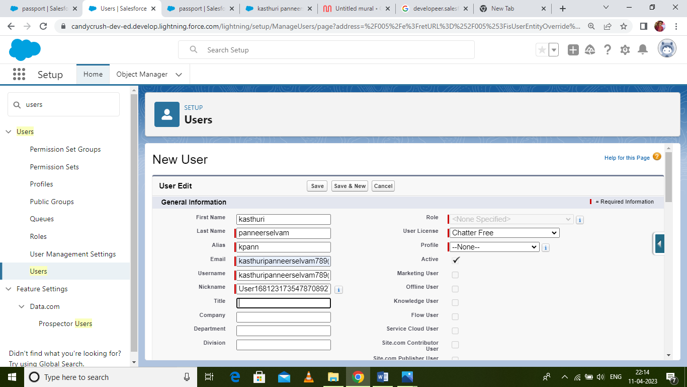

Milestone-5 User:

A user is anyone who logs in to Salesforce. Users are employees at your company, such as sales reps,

managers, and IT specialists, who need access to the company's records. Every user in Salesforce has

a user account.

Activity-1:

Creation of User

1) Navigate to setup in quick find search bar

2) Type user in and select it and click on new user.

3) Give the first name and last name.

4) Enter your email in the email field.

5) Enter username; it must be unique.

6) Select the user license of salesforce.

7) In the profile field select standard user.

8) At the bottom of the page check the box to generate a new password and notify the user

immediately.

# Trailhead Profile Public URL

**Team Lead: https://trailblazer.me/id/kasthupanneer**

**Team member 1-** [**https://trailblazer.me/id**/minupandiyan](https://trailblazer.me/id/minupandiyan)

**Team member 2-** [**https://trailblazer.me/id/priyuravi**](https://trailblazer.me/id/priyuravi)

**Team member 3-https://trailblazer.me/id/manibalu**

1. **ADVANTAGES**

Having huge amount interactions enables an organization to build up a clearer picture of its customers. It allows for deep insights to identify what the company is doing right as well as where it’s weak when it comes to managing its customers. With a CRM system, the most profitable customers can be identified with the view to more time being spent targeting them. The CRM software also lets a business tailor its market communications to achieve more effective results and, hence a greater turn on investment I sales and marketing.

DISADVANTAGE

There ae risks associated with keeping a lot of data in one places. With stringent regulations surrounding data (GDOR, for example), businesses face severe penalties in the event of security breace. When it comes to CRM software, it is vital that security processes are put in places to protect clients’ per clients information. This can be a significant expense for a business.

# APPLICATIONS

This will help you to tracks and manage the availability of visa slot, which are appointments that are required for certain visa application.

# CONCLUSION

Customer relationship Management enables a company to align its strategy with the needs of his customer in order to best meet those needs and thus ensure long-term customer loyalty.

# FUTURE SCOPE

The project scope is a way to set boundaries on our project and define exactly what goals, deadlines, and project deliverables you’ll be working towards. By clarifying you project scope, you can ensure you hit your project goals and objectives without delay or overwork. Define your project scope isn’t a one-person job.